**Table of Contents**

Introduction: 3

TASK 1 5

Screenshot from the Mininet Wi-Fi GUI 5

Prior to Mobility: 5

At the completion of mobility: 5

Ping results: 6

STA1 <- - -> STA2 6

STA2 <- - -> STA3 6

STA1 <- - -> STA3 6

STA1 <- - -> STA4 7

A TCP flow of 1GB using the socket assigned: 7

The server and the client statistics 7

Wireshark, while the transfer is in progress 7

Wireshark, throughput when the transfer is complete 8

I/O, when the transfer is complete 8

TASK 2 9

ICMP stream 9

sta4ad < - - -> sta5ad 9

sta5ad < - - -> sta6ad 9

sta4ad < - - -> sta6ad 9

sta7M < - - -> sta8M 10

Sta8M < - - -> sta9M 10

sta7M < - - -> sta9M 10

Analysis 11

TASK 3 12

ONOS GUI 12

ICMP stream 12

Link configurations 13

Links status: 13

TASK 4 14

UDP flow to total of 2GB traffic using the port assigned 14

I/O Graph 14

ONOS GUI Server and Client 15

UDP Wireshark 15

Video stream 16

Wireshark while streaming 16

Packets route while streaming 17

Capture File Properties 17

Analysis 18

References: 18

# Introduction:

Simulation of wireless networks is important at all stages of their life including the design, operational, and testing stages. Simulation is used to predict the performance of a wireless network‘s architecture, protocol, device, topology, etc. It is a cost-effective and flexible technique to performance evaluation of wireless systems. This chapter aims at reviewing the main aspects of wireless systems including wireless node object model, radio propagation, physical and media access control layers, and wireless network architectures. Then we review the simulation tools and packages that are optimized for this task. Case studies on simulation of wireless network systems are presented to demonstrate the main concepts.

We used these network simulation tools during this period:

**Mininet:**

Mininet is a network emulator which creates a network of virtual hosts, switches, controllers, and links. Mininet hosts run standard Linux network software, and its switches support OpenFlow for highly flexible custom routing and Software-Defined Networking.

Mininet supports research, development, learning, prototyping, testing, debugging, and any other tasks that could benefit from having a complete experimental network on a laptop or other PC.

**ONOS:**

ONOS stands for Open Network Operating System. ONOS provides the control plane for a software-defined network (SDN), managing network components, such as switches and links, and running software programs or modules to provide communication services to end hosts and neighboring networks.

The most important benefit of an operating system is that it provides a useful and usable platform for software programs designed for a particular application or use case. ONOS applications and use cases often consist of customized communication routing, management, or monitoring services for software-defined networks. Some examples of things which you can do with ONOS, and software written to run on ONOS, may be found in Apps and Use Cases.

**Wireshark:**

Wireshark is a network packet analyzer. A network packet analyzer presents captured packet data in as much detail as possible.

You could think of a network packet analyzer as a measuring device for examining what is happening inside a network cable, just like an electrician uses a voltmeter for examining what’s happening inside an electric cable (but at a higher level, of course).

In the past, such tools were either very expensive, proprietary, or both. However, with the advent of Wireshark, that has changed. Wireshark is available for free, is open source, and is one of the best packet analyzers available today.

**Iperf:**

Iperf is a tool for network performance measurement and tuning. It is a cross-platform tool that can produce standardized performance measurements for any network. Iperf has client and server functionality and can create data streams to measure the throughput between the two ends in one or both directions. Typical Iperf output contains a time-stamped report of the amount of data transferred and the throughput measured.

# TASK 1

## Screenshot from the Mininet Wi-Fi GUI

### Prior to Mobility:

* 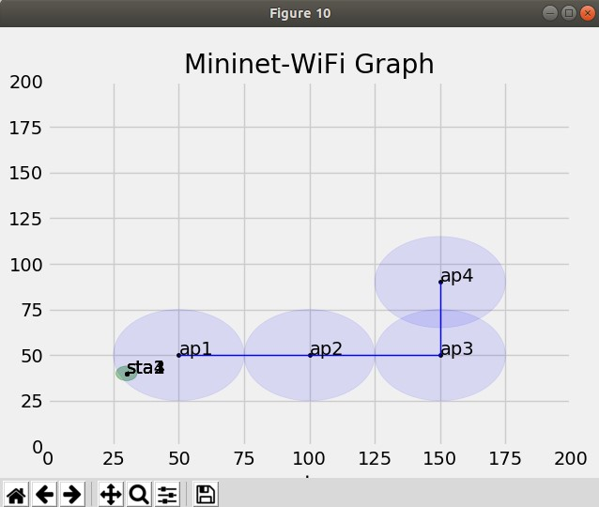

### At the completion of mobility:

* 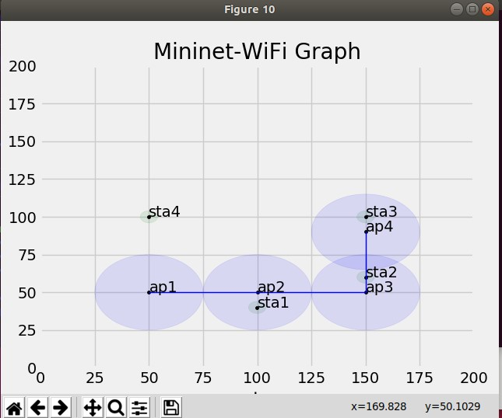

•

## Ping results:

### STA1 <- - -> STA2

* 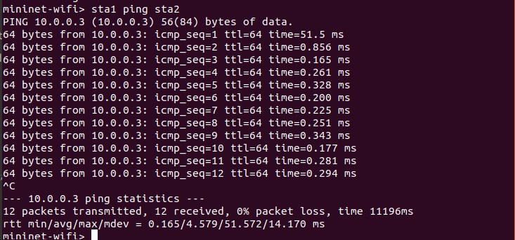

### STA2 <- - -> STA3

* 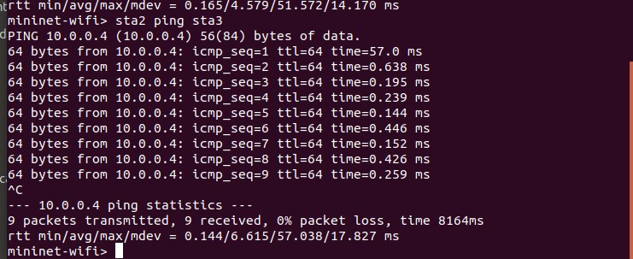

### STA1 <- - -> STA3

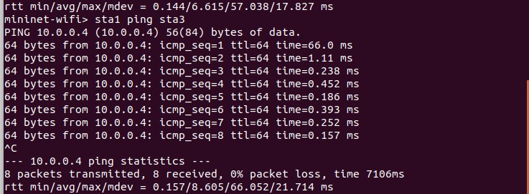

### STA1 <- - -> STA4

* 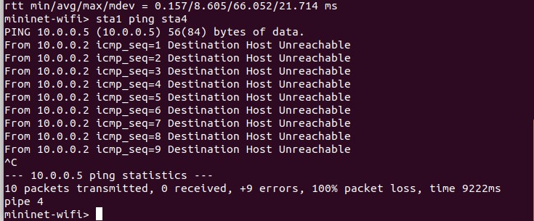

## A TCP flow of 1GB using the socket assigned:

### The server and the client statistics

* 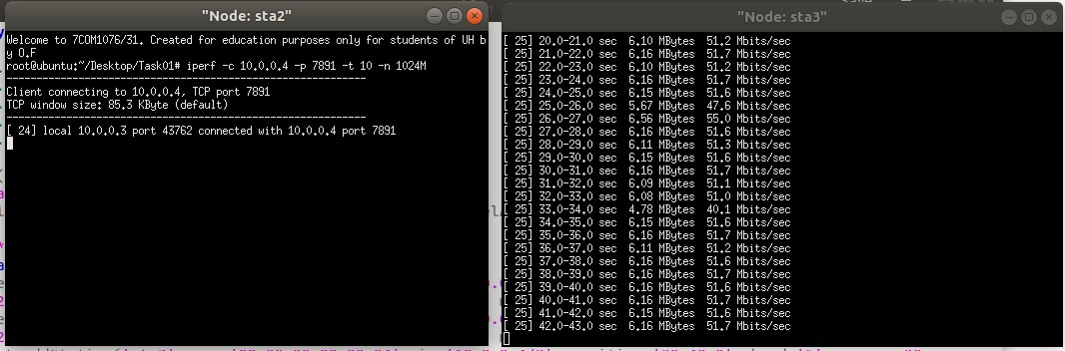

### 

### Wireshark, while the transfer is in progress

* 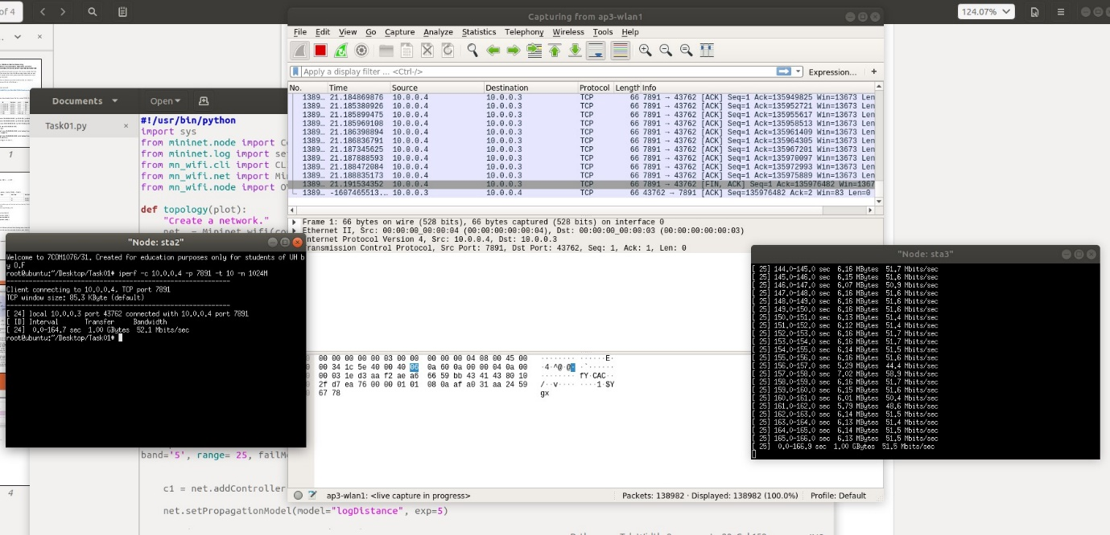

### Wireshark, throughput when the transfer is complete

* 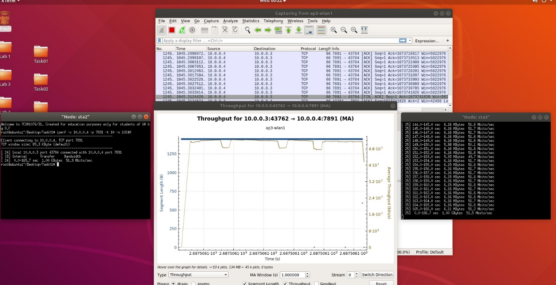

### I/O, when the transfer is complete

* 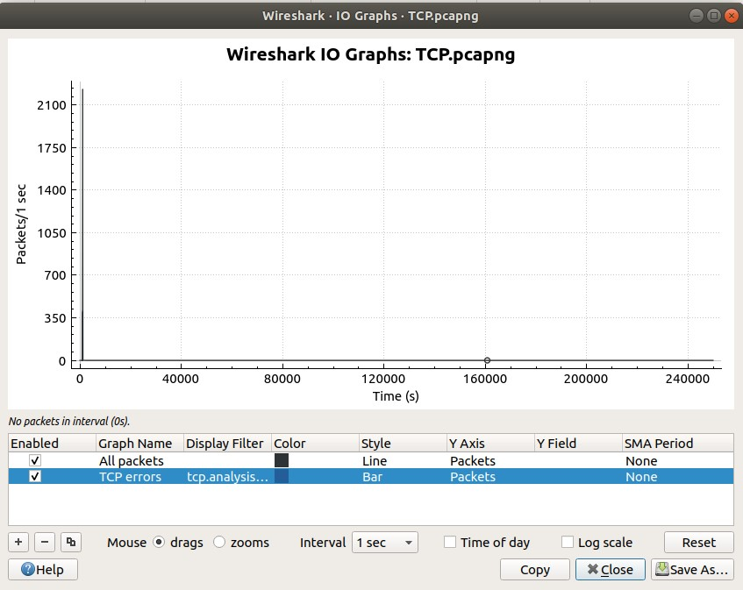

# TASK 2

## ICMP stream

### sta4ad < - - -> sta5ad

* 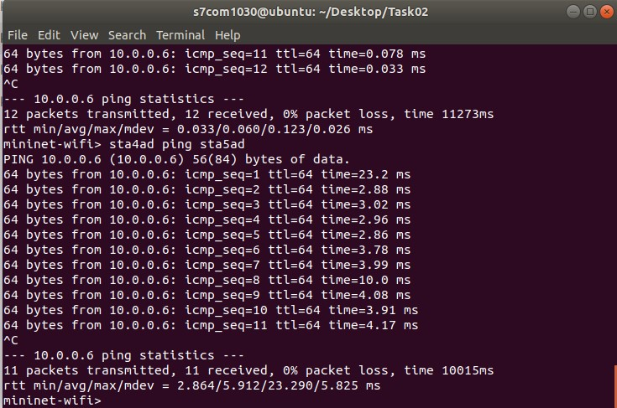

### sta5ad < - - -> sta6ad

* 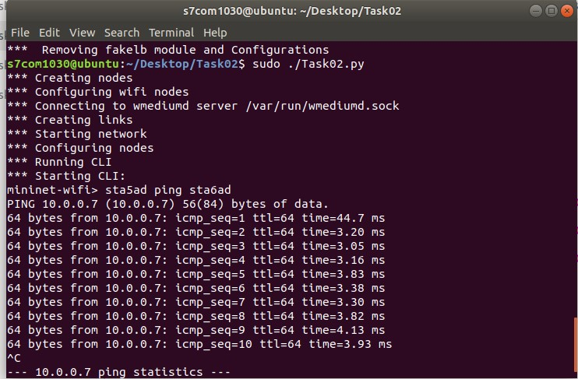

### sta4ad < - - -> sta6ad

* 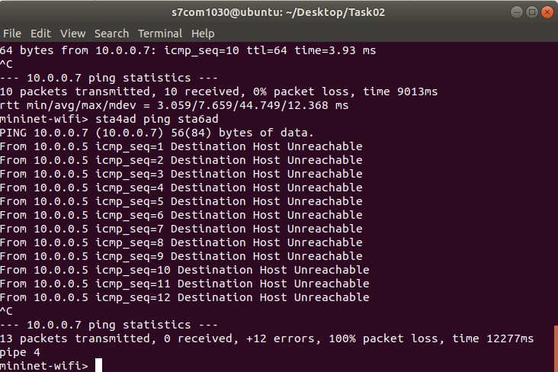

### sta7M < - - -> sta8M

* 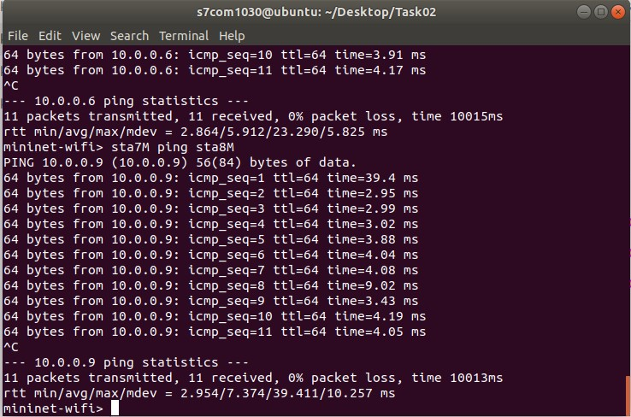

### 

### Sta8M < - - -> sta9M

* 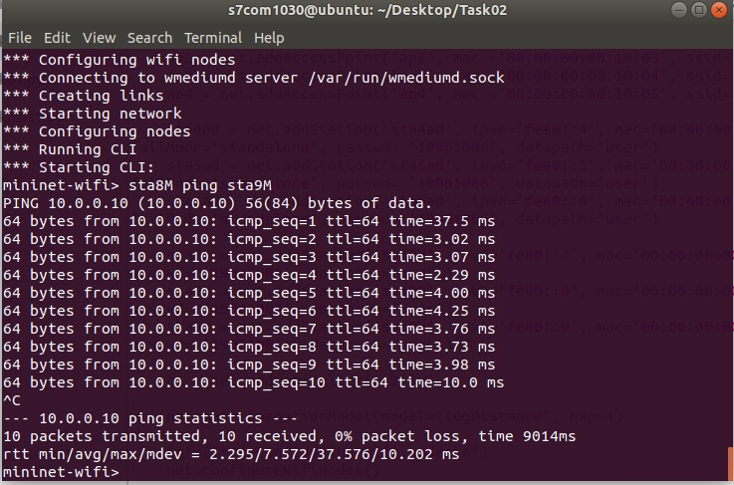

### sta7M < - - -> sta9M

* 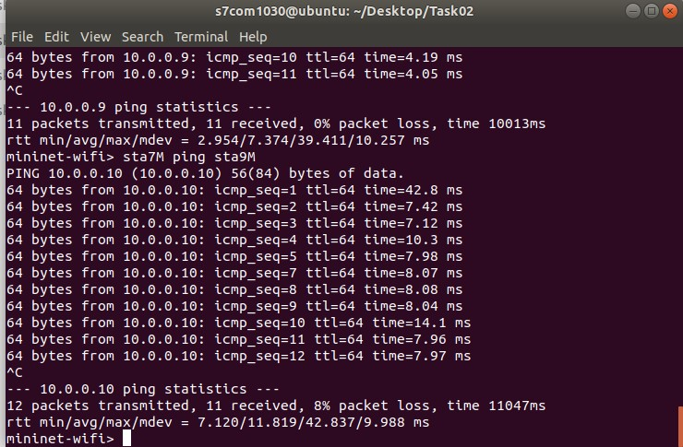

## Analysis

o Calculate TCP Success rate, this can be done by the statistics collected

**Results:**

|  |  |
| --- | --- |
| Link bandwidth (Mbit/s): | 52.1 |
| Max achievable TCP throughput limited by TCP overhead (Mbit/s): | 49.4577 |
| Bandwidth-Delay Product (BDP) (bit): | 837455400 |
| Minimum required TCP RWND (Byte): | 104681925 |
| Max TCP throughput limited by packet loss (Mathis et.al. formula) (Mbit/s): | 0.726639 |
| Max TCP throughput limited by TCP RWND (Mbit/s): | 0.042454 |
| Expected maximum TCP throughput (Mbit/s): | **0.042454** |
| Minimum transfer time for a 1000 Megabytes file (D:H:M:S): | **2:04:20:39** |

o Critically evaluate the reason for success or failure of the ICMP streams between sta4ad < - - -> sta6ad and sta7M < - - -> sta9M. Conduct a discussion of the results with evidence (screenshots) and reference:

sta4ad cannot ping sta6ad but sta7M can ping sta9M this is because they are in a mesh network and sta8M transfers the data and we can see that the ping time for sta7M to sta9M equals to the ping time form sta7M to sta8M + sta8M to sta9M.

o If the nodes are in mobility during the transmission of the TCP stream, will the performance deviate from the collected in any way? Conduct a discussion based on this experiment. If needed add reference from background research to further support your claims.

Yes, because a Handoff between the new access point and the old access point is taking place when the stations are moving between the access points.

o Critically evaluate why STA1 < - - > STA4 ping fail in Task 1? How can a successful ping be achieved?

We cannot ping from Sta1 to Sta4 because sta4 is not in range of any of the access points

# TASK 3

## ONOS GUI

* 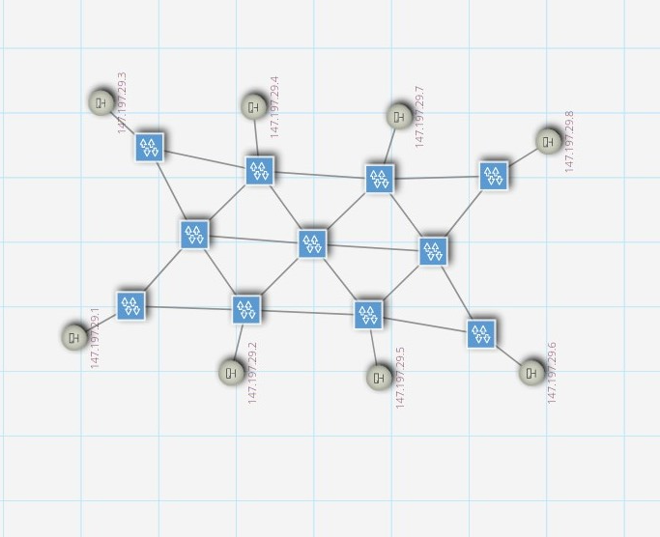

## 

## ICMP stream

* 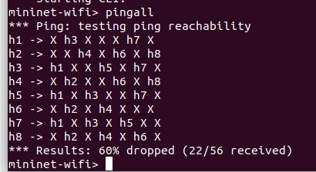

•

## Link configurations

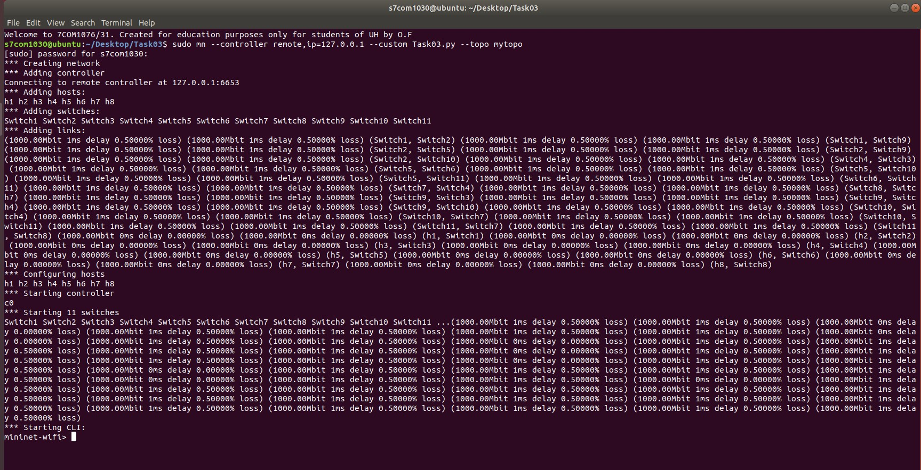

## 

## Links status:

* 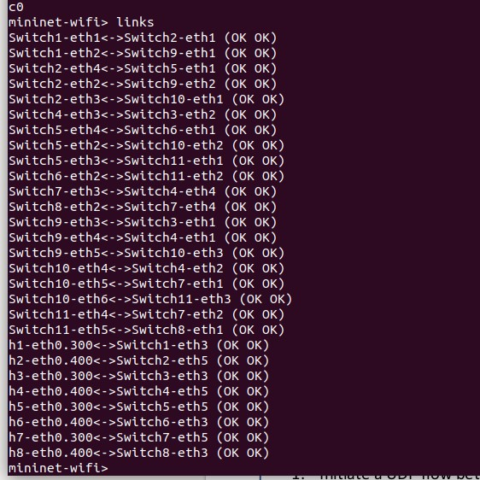

# TASK 4

## UDP flow to total of 2GB traffic using the port assigned

* 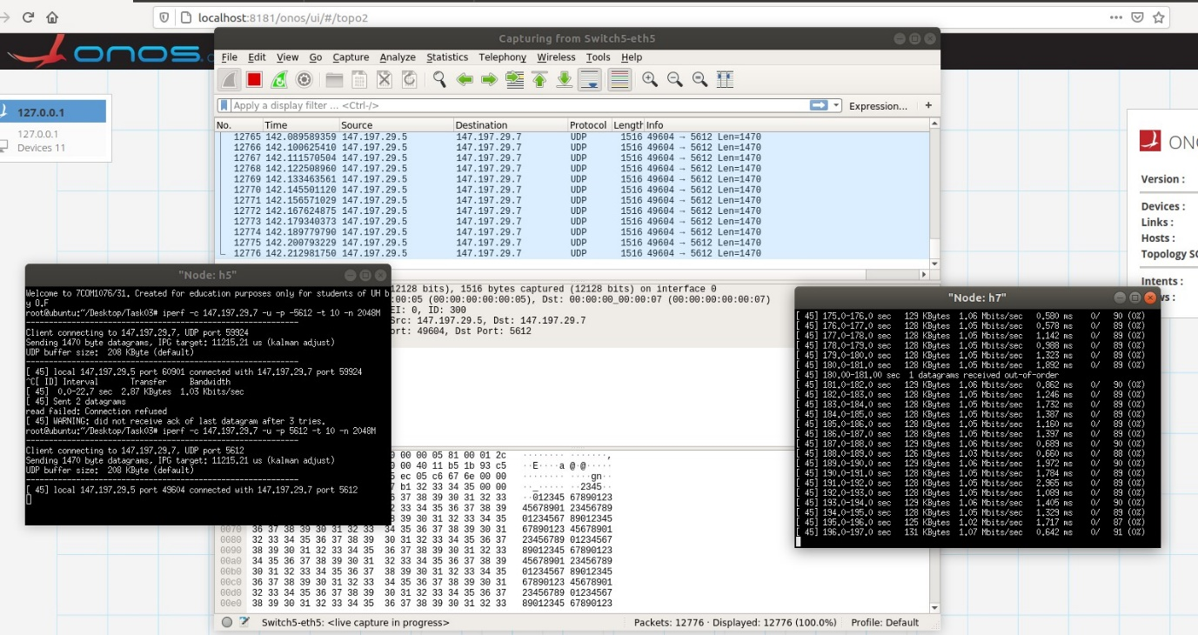

## 

## I/O Graph

* 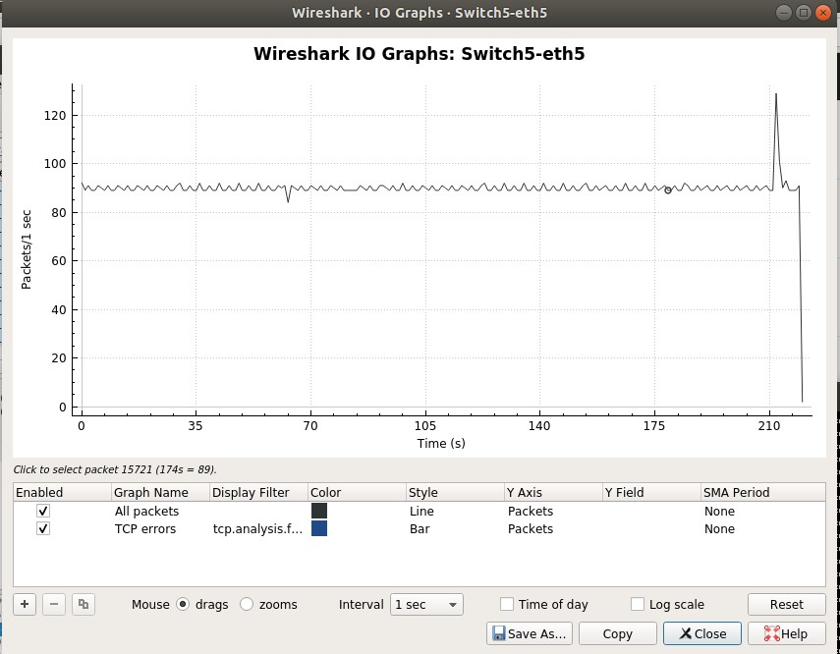

## ONOS GUI Server and Client

* 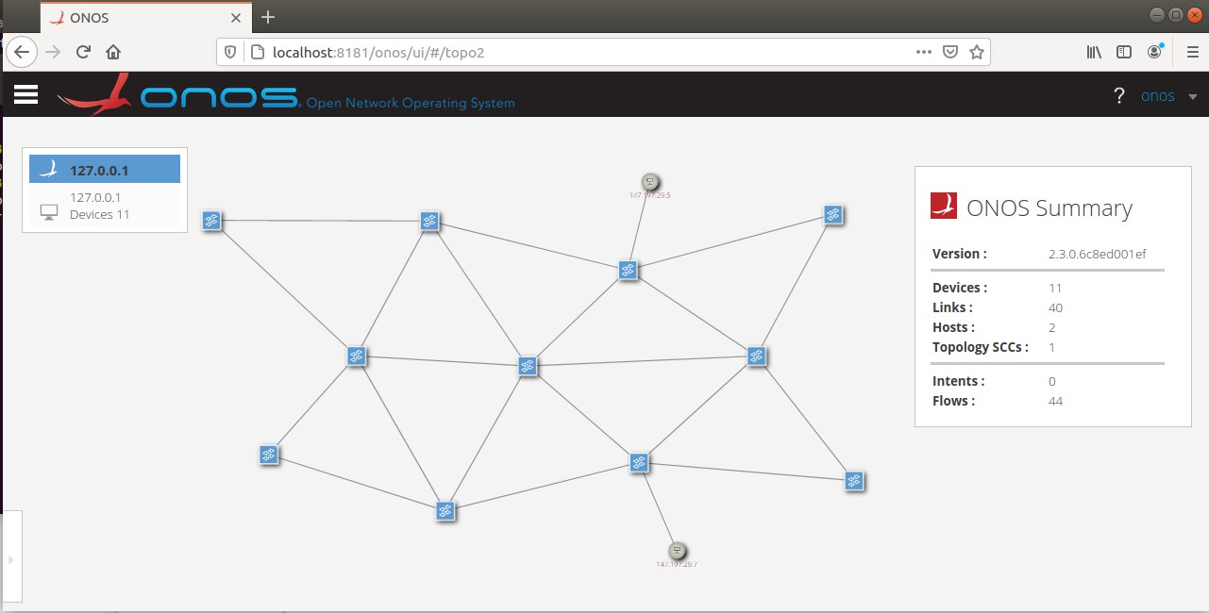

## UDP Wireshark

* 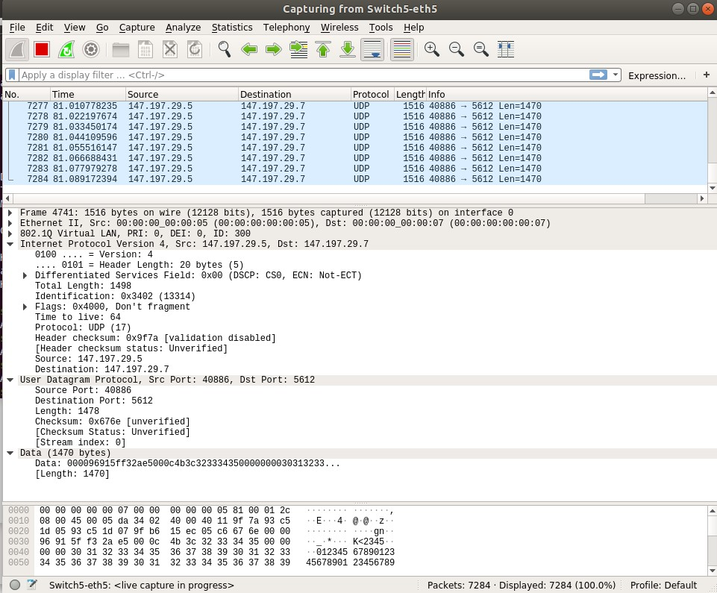

## Video stream

* 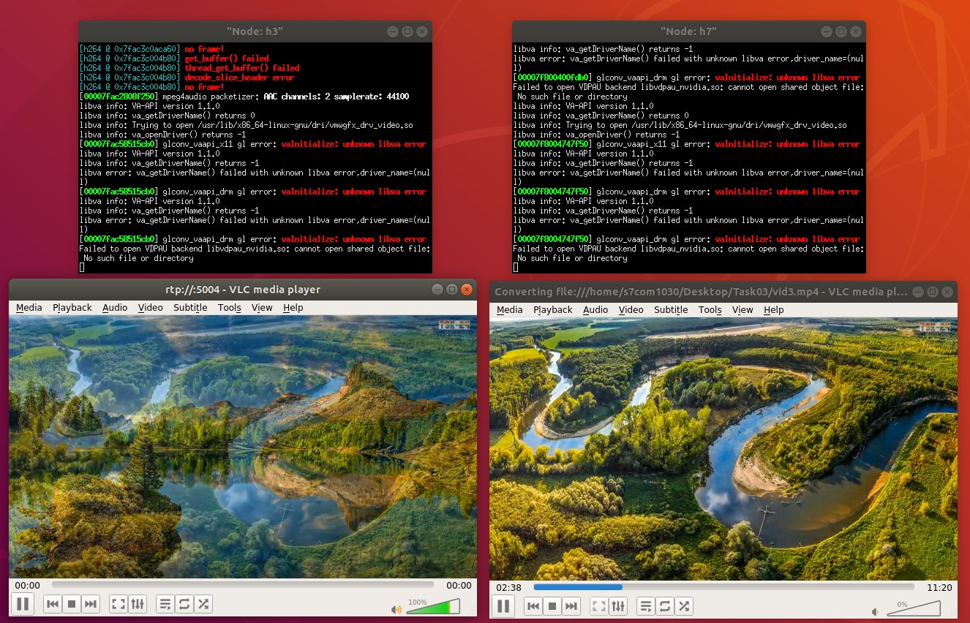

## Wireshark while streaming

* 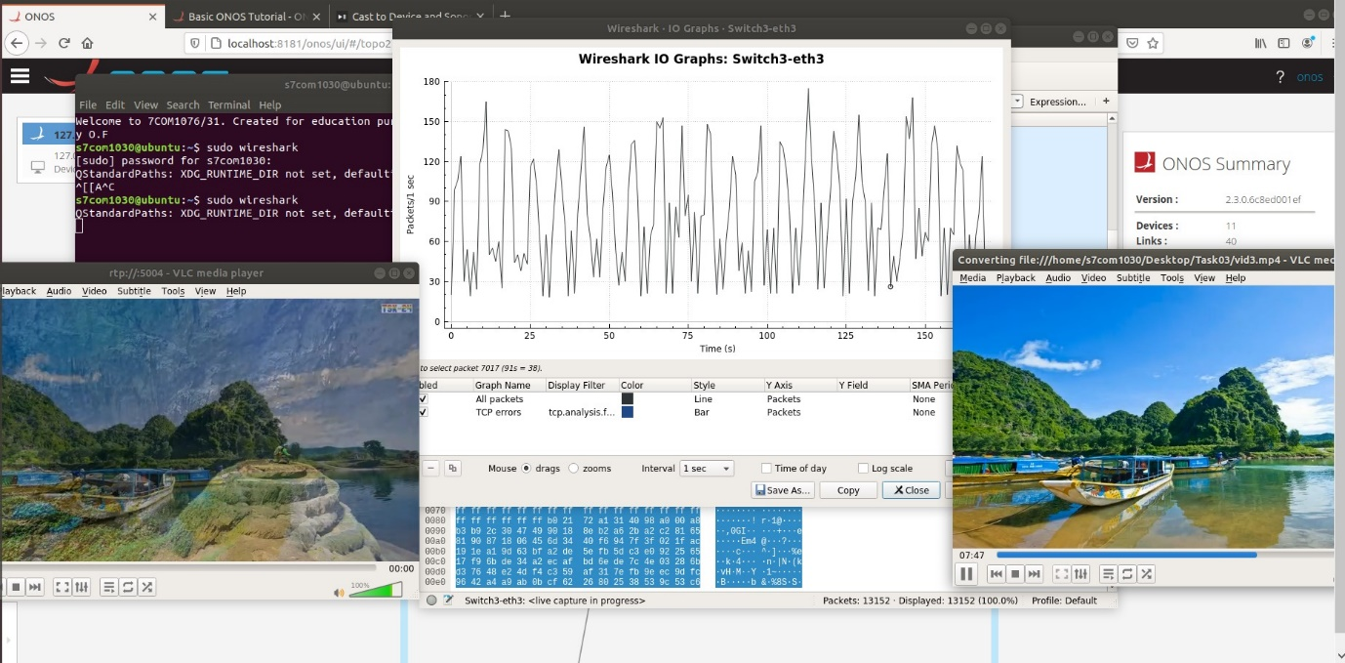

## Packets route while streaming

* 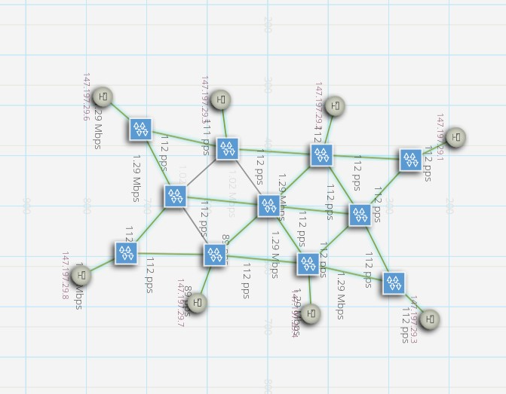

## Capture File Properties

## Analysis

o Should there be more packet loss and delay, should you expect the results to deviate from what you have acquired?

For this task, we are using ONOS and because of our own data connection (internet disconnections, etc.) we are having more packet losses and jitter than expected.

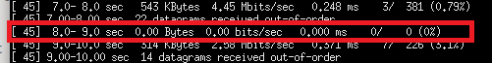

o Comment on how the variables such as packet loss and delay have contributed towards the overall performance of your network.

Because we are using UDP, there is no retransmissions to ensure reliable messaging. therefore, we are sending the data much faster, but we are also losing some of it.

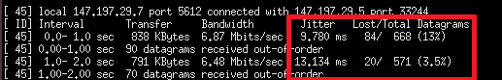

# References:

Obaidat, M.S. and Green, D.B. (2003). Simulation of Wireless Networks. *Applied System Simulation*, pp.115–153.

Fontes, R.R., Afzal, S., Brito, S.H.B., Santos, M.A.S. and Rothenberg, C.E. (2015). Mininet-WiFi: Emulating software-defined wireless networks. *2015 11th International Conference on Network and Service Management (CNSM)*.

GUEANT, V. (2013). *iPerf - The TCP, UDP and SCTP network bandwidth measurement tool*. [online] Iperf.fr. Available at: <https://iperf.fr/>.

‌ Mininet Team (2018). *Mininet: An Instant Virtual Network on your Laptop (or other PC) - Mininet*. [online] Mininet.org. Available at: <http://mininet.org/>.

Wireshark.org. (2019). *Chapter 1. Introduction*. [online] Available at: <https://www.wireshark.org/docs/wsug_html_chunked/ChapterIntroduction.html>.